**Higling Grid Row when Clicking the row**

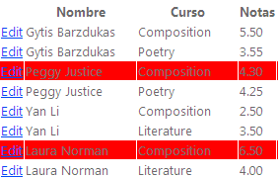

<script src="Scripts/jquery-1.3.min.js" type="text/javascript"></script>

<script type="text/javascript">

$(document).ready(function () {

$("tr").filter(function () {

return $('td', this).length && !$('table', this).length

}).click(function () {

$(this).toggleClass('currRow');

});

});

</script>

<style type="text/css">

.currRow

{

background-color:Gray;

cursor:pointer;

}

</style>

<script src="Scripts/jquery-1.4.1.min.js" type="text/javascript"></script>

<script type="text/javascript">

$(document).ready(function () {

$("#MainContent_GridView1 **tr**").click(function () {

$(this).css("background-color", "red");

});

});

</script>

To prevent header to be highlight

if (GridView1.Rows.Count > 0)

{

GridView1.UseAccessibleHeader = true;

GridView1.HeaderRow.TableSection = TableRowSection.TableHeader;

//GridView1.FooterRow.TableSection = TableRowSection.TableFooter;

}